Proposal for Personalization

1. Modify Curiosity Dataset for our use case.
2. Implement End to End Model, at least for Utterance Use-case.
3. Response Contrastive Loss for the Grounding (Knowledge)
4. FoCus has Knowledge Grounding (True Monument vs Other Monument), which makes the task easier. Same Idea in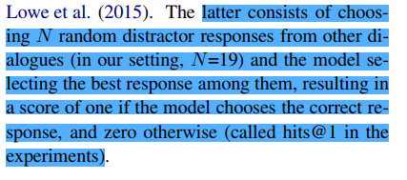 Personalising Dialogue Agents paper.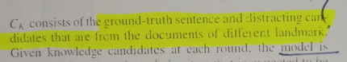
5. Can provide Persona to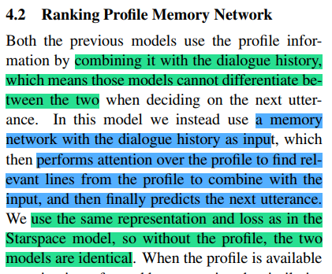 ChatBot also, use Personalising Dialogue Agents paper.
6. Use Semantic Similarity for Retrieval Module in place of TF-IDF as it doesn’t work well for longer text. Can also use Summarisation in place of Retrieval
7. FoCus, the persona, and dialog history are concatenated, so the model cannot differentiate. Use **Memory Network. Also Key-Value Profile Memory Network.**
8. While working with user queries, Use NER based technique to find relevant information from the query and then use that relevant information for knowledge grounding.
9. Built Persona while interactions also. (You Impress Me)

**Personalizing Dialogue Agents: I have a dog, do you have pets too? :** <https://arxiv.org/pdf/1801.07243.pdf> **- Read**

**ParlAI :** <https://github.com/facebookresearch/ParlAI>

**Personalization in Goal-oriented Dialog:** <https://arxiv.org/pdf/1706.07503.pdf> **- Reading**

**LEARNING END-TO-END GOAL-ORIENTED DIALOG:** <https://arxiv.org/pdf/1605.07683.pdf>

**You Impress Me: Dialogue Generation via Mutual Persona Perception :** <https://arxiv.org/pdf/2004.05388v1.pdf>